Assignment - 4

You have been asked to:

● Use the previous deployment of ansible cluster

● Configure the files folder in “ansible-new” role with index.html which should be replaced

with the original index.html

● Configure the handlers folder in “ansible-new” role for restarting the nginx service

All of the above should only happen on the slave which has nginx installed

1. Created a custom index.html file in the files folder

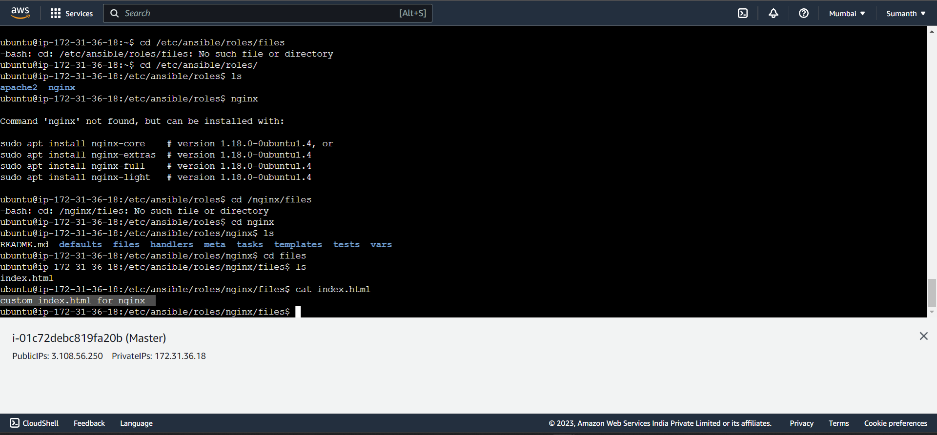

1. Specified the roles

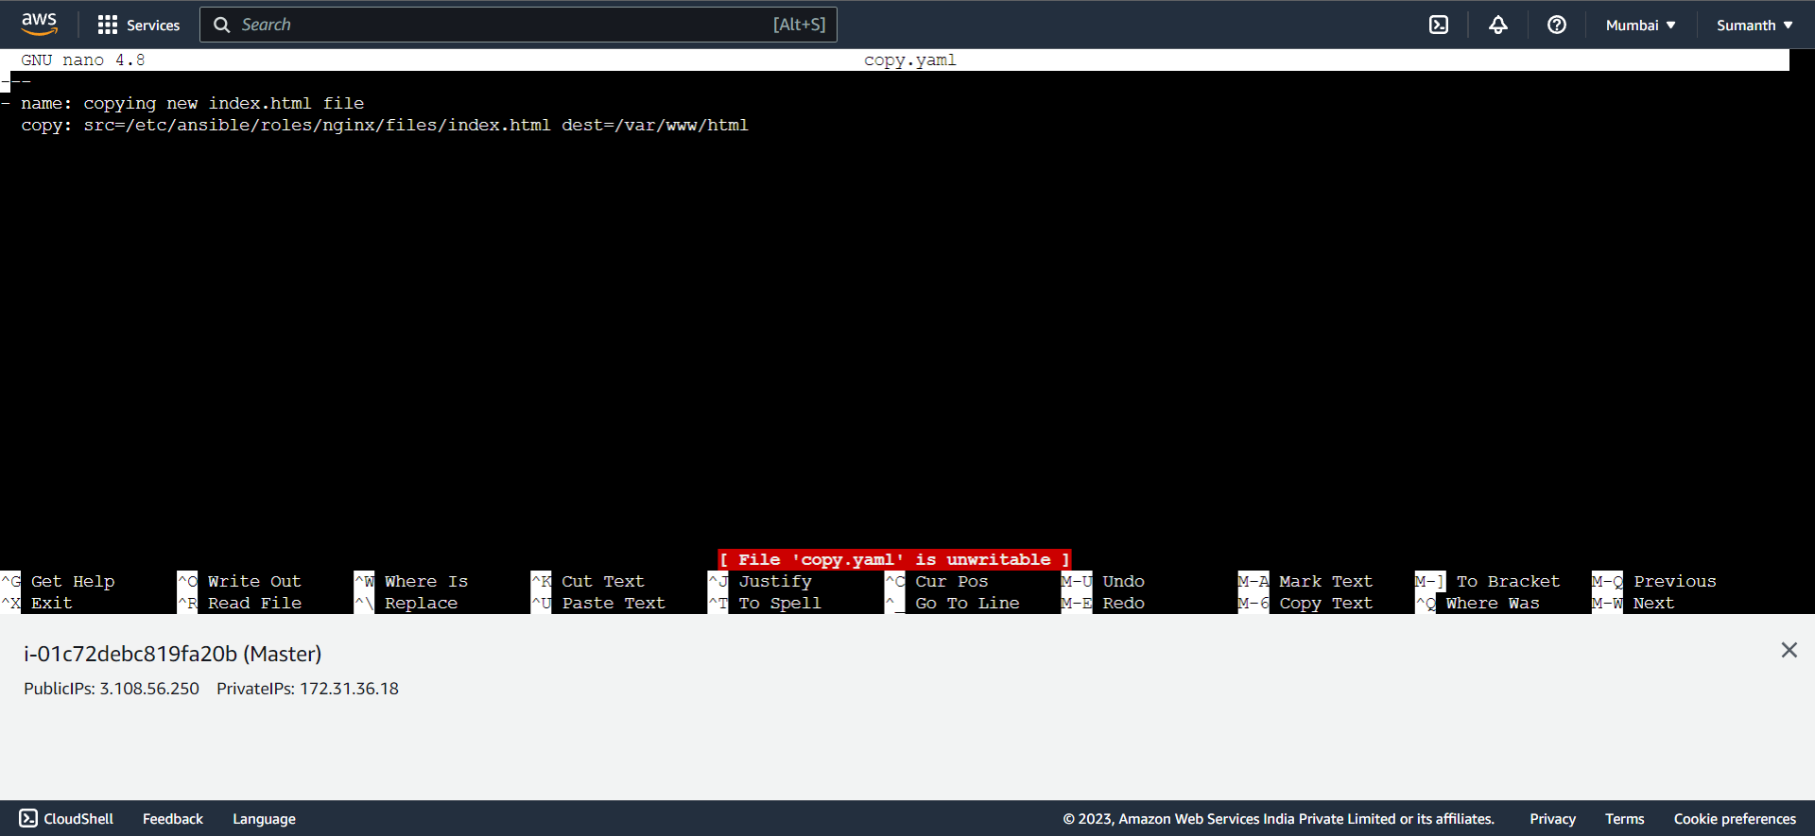

1. Included the task in main.yml

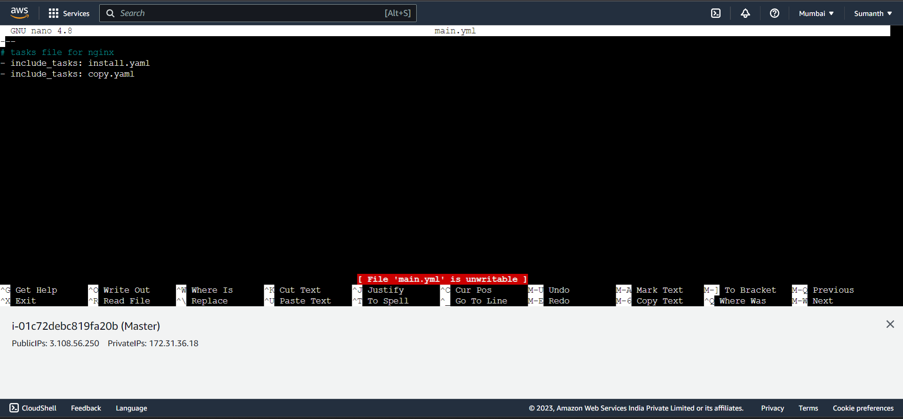

1. Specified the playbook

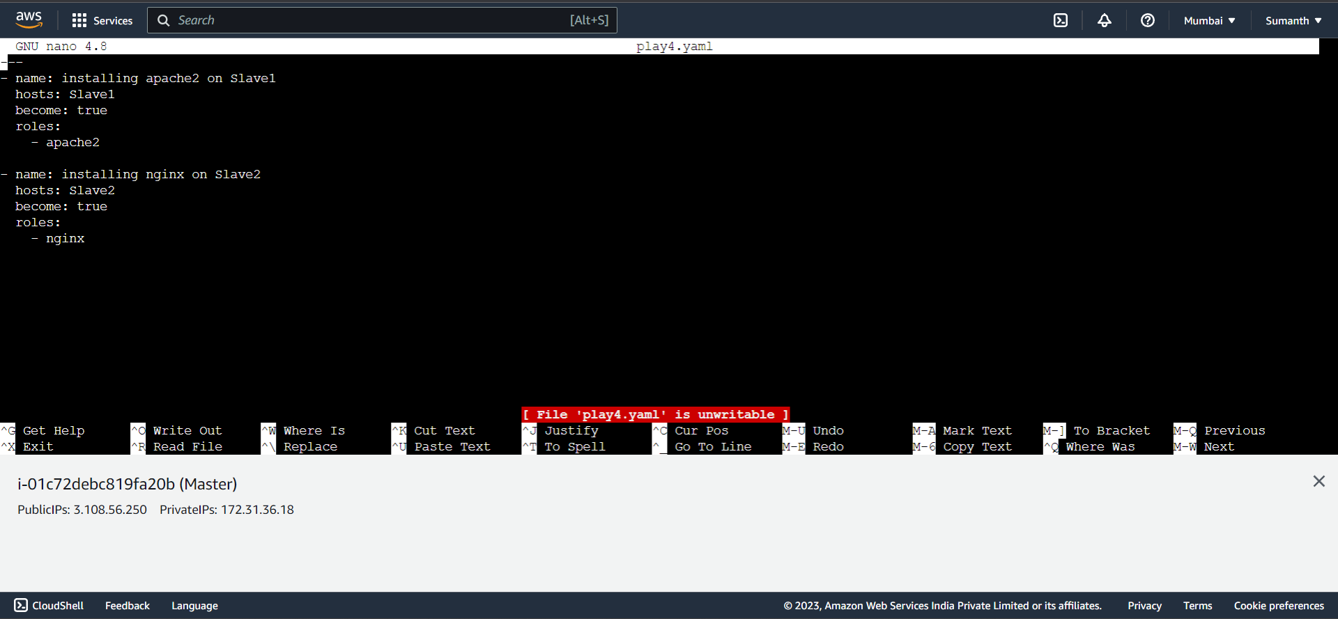

1. As requested, replaced the original index.html with custom text

